Quantitative Risk Management, Homework 1
Group 6, Brazil (B3) · Members: ARNOUX, TOPANELIS, TONINI, BUSON · Deadline: 16 November 2026

Responsibilities
Question | Member in charge | Roles of other members
Q1 Data | [to fill] | [to fill]
Q2 Descriptive analysis | [to fill] | [to fill]
Q3 GARCH and portfolio | [to fill] | [to fill]
Q4 VaR with GARCH (Cases 1 and 2) | [to fill] | [to fill]
Q5 GEV | [to fill] | [to fill]
Q6 GPD | [to fill] | [to fill]
Q7 VaR with EVT (Cases 3 to 5) | [to fill] | [to fill]
Q8 Comparison of VaR sequences | [to fill] | [to fill]
Q9 Expected Shortfall (bonus) | [to fill] | [to fill]

Executive summary
We analyse 15 large-cap Brazilian equities (B3, daily data in BRL, 26/09/2016 to 30/09/2026) and a randomly weighted portfolio, PORT. The main findings are:
- Returns are far from normal. Excess kurtosis ranges from 3.7 to 24.1, skewness is negative for all 15 stocks, and days beyond three standard deviations are 4 to 6 times more frequent than under normality. Absolute and squared returns are strongly autocorrelated (volatility clustering), and variance and correlation are not constant over time, with a sharp break in March 2020.
- GARCH(1,1) captures the volatility dynamics but not the tails. Persistence (alpha + beta) lies between 0.85 and 0.99. The standardized residuals Z are still non-normal for all 16 series, and a Student t is preferred by BIC for 15 of 16.
- Extreme value theory fits the tails of Z well. Both the GEV and the GPD give a positive shape parameter (heavy, power-law tails) for almost all series, and the 99% quantile of Z is between 2.35 and 2.90, against 2.33 under normality.
- Out of sample (249 days), the Normal VaR at 99% is violated 47 times over the 16 series (about 40 expected), whereas the t and EVT-based VaR give 34 to 36 violations. The Normal Expected Shortfall underestimates the average loss on violation days (4.60% predicted against 5.53% realised), while the GPD-based ES is close (5.88% against 5.99%).

1. Data (Question 1)

1.1 Source and selection criteria
Data were downloaded from LSEG Workspace. We used the Equity Screener with the following settings: Country of Exchange = Brazil; the screener's "Active, Public, Primary" setting (primary quotes only); Company Market Cap ranked in the top of the market; and an IPO date on or before 30/09/2016, so that a history of at least ten years exists. This left 23 candidates, from which we selected 15 assets with the following criteria:
- Large-cap and primary quote: the largest companies by market capitalization, listed on B3 under their primary quote (RIC suffix .SA).
- One share class per company, to avoid near-duplicate and almost perfectly correlated series. For the same reason we excluded Itausa (ITSA4), a holding whose main asset is Itau Unibanco (ITUB4).
- Sector diversification, to avoid a sample dominated by financials: oil and gas, mining, steel, banks, beverages, industrials, aerospace, utilities, telecoms and consumer services.
- Data integrity (not sample size): we excluded companies whose current RIC has a history shorter than the sample because of share-class conversions. Suzano (SUZB3) starts on 17/11/2017, after its conversion to a single class of ordinary shares, so it was replaced by Eneva (ENEV3).
Sector | Assets (RIC)
Oil and gas | PETR4
Mining and steel | VALE3, GGBR4
Banks | ITUB4, BBDC4, BBAS3
Consumer / beverages / services | ABEV3, RENT3
Industrial and aerospace | WEGE3, EMBJ3
Utilities | EQTL3, SBSP3, CPLE3, ENEV3
Telecoms | VIVT3
Caveat. Ranking by current market capitalization introduces some survivorship bias: companies that were large in 2016 but later shrank or delisted are not in the sample.

1.2 Data treatment
- Series: daily close prices from LSEG Historical Pricing, 26/09/2016 to 30/09/2026. [Group to confirm here whether the split/dividend adjustment option was active in the export.]
- Currency: all series are in Brazilian reais (BRL). This is equivalent to assuming that the exchange-rate risk is fully hedged, so the analysis measures equity risk only. Converting to USD would add the BRL/USD volatility, raise the correlation across stocks (common FX factor) and fatten the left tail, since Brazilian equity sell-offs usually coincide with BRL depreciation.
- Cleaning (script 01_clean_data.py): the raw LSEG files contain a header and a statistics block, dates in a local format and decimal commas. The script locates the data block, converts dates to ISO format and prices to numbers, sorts the data from oldest to newest, merges the 15 series on the date and removes non-trading days (dates on which fewer than half of the assets have a price). After merging, no asset has a missing value, so all series share the same calendar of 2,487 trading days.
- Log-returns: X_t = ln(P_t / P_{t-1}), giving 2,486 daily returns per asset (27/09/2016 to 30/09/2026).
- Stale prices: the share of exactly-zero returns is high for CPLE3 (9.9%) and ENEV3 (5.1%), against 0.8% to 3.3% for the others. This points to thin trading or repeated prices for these two stocks and makes their serial-correlation and volatility estimates less reliable.
- In-sample / out-of-sample split (Q3 onward): in-sample 27/09/2016 to 30/09/2025 (2,237 returns); out-of-sample 01/10/2025 to 30/09/2026 (249 returns).

2. Descriptive analysis of the log-returns (Question 2)
This section studies the 2,486 daily log-returns of each asset on the full sample (script 02_descriptive.py). The aim is to check which of the usual stylized facts hold for Brazilian large caps, because the risk models used later (GARCH, EVT) are built on them.

2.1 Distribution: asymmetry and deviations from normality
Table 1 reports annualized volatility (daily standard deviation times the square root of 250), the extremes, skewness and excess kurtosis (zero for a normal distribution).
Asset | Ann. vol (%) | Min (%) | Max (%) | Skewness | Excess kurtosis | Zero returns (%)
ABEV3 | 26.5 | -17.1 | 14.3 | -0.17 | 11.1 | 3.3
BBAS3 | 36.1 | -22.2 | 15.7 | -0.75 | 12.0 | 1.5
BBDC4 | 33.3 | -19.1 | 15.6 | -0.61 | 11.4 | 1.9
CPLE3 | 31.4 | -15.6 | 17.9 | -0.20 | 9.2 | 9.9
EMBJ3 | 45.1 | -30.8 | 20.3 | -0.18 | 11.1 | 1.3
ENEV3 | 33.9 | -21.5 | 14.0 | -0.49 | 10.6 | 5.1
EQTL3 | 26.6 | -11.5 | 8.0 | -0.20 | 3.7 | 1.7
GGBR4 | 39.1 | -19.8 | 16.1 | -0.36 | 5.5 | 1.4
ITUB4 | 28.4 | -12.8 | 10.5 | -0.14 | 3.8 | 1.6
PETR4 | 41.5 | -35.3 | 20.3 | -1.85 | 24.1 | 3.1
RENT3 | 42.0 | -26.7 | 23.7 | -0.26 | 10.6 | 1.0
SBSP3 | 35.1 | -19.7 | 16.1 | -0.09 | 8.5 | 2.7
VALE3 | 36.0 | -28.1 | 19.3 | -0.51 | 15.2 | 0.8
VIVT3 | 26.2 | -13.1 | 11.6 | -0.15 | 6.4 | 2.6
WEGE3 | 33.5 | -23.1 | 13.0 | -0.53 | 10.7 | 1.9
Table 1. Summary statistics of daily log-returns, 27/09/2016 to 30/09/2026. Daily means range from 0.007% to 0.110%.
Statistical reading.
- Volatility ranges from 26% (VIVT3, ABEV3) to 45% (EMBJ3), with an average of 34%, high compared with developed markets.
- Asymmetry: skewness is negative for all 15 stocks (average -0.43), and the largest daily loss exceeds the largest daily gain for 14 of 15 (the exception is CPLE3). PETR4 stands out with skewness -1.85.
- Tails: excess kurtosis is positive for every stock, between 3.7 (EQTL3, ITUB4) and 24.1 (PETR4), with a median of about 10.6. For comparison, a Student t distribution with 5 degrees of freedom has an excess kurtosis of 6. All series are therefore leptokurtic (stylized fact U6).
- Normality tests: the Jarque-Bera test (H0: skewness 0 and excess kurtosis 0) gives a p-value below 0.001 for all 15 assets, and the Anderson-Darling statistics are far above the 1% critical value. The normal Q-Q plots (Figure 1) show the inverted-S shape typical of heavy tails: the centre fits, but both tails lie far from the line.
Economic reading. Negative skewness and fat tails mean that large losses are more likely than a normal model suggests, and that the left tail is heavier than the right. PETR4 combines the highest kurtosis and skewness: it is a state-controlled company whose price reacts to oil prices, political interference in pricing and governance news, so that it is exposed to abrupt jumps. At the other end, defensive or regulated names (EQTL3, ITUB4) have the lightest tails.
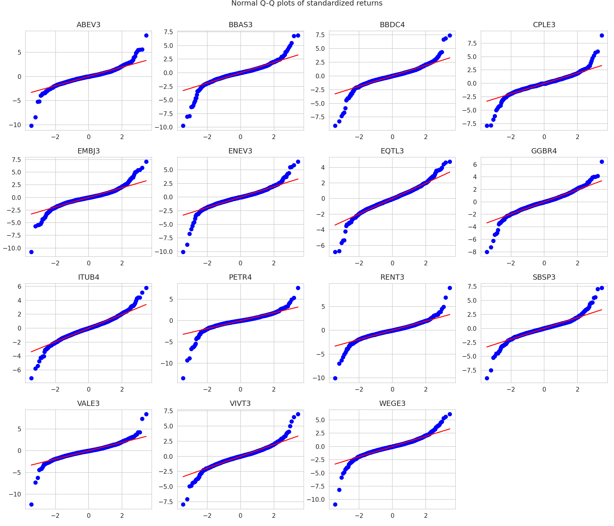

2.2 Occurrence of extreme events
We standardize each return, z = (r - mean) / standard deviation, and count the days with |z| above 3. Under normality the probability is 0.27%, i.e. about 6.7 days out of 2,486.
- Beyond 3 standard deviations: between 25 days (VALE3) and 40 days (SBSP3) are observed, i.e. 3.7 to 6.0 times the normal benchmark.
- Beyond 5 standard deviations: 5 to 12 days per stock, whereas a normal would give about 0.0014 days. Such moves practically never happen under normality, but occur roughly once a year per stock in the data.
- Symmetry of the extremes: among |z| > 3 days, losses outnumber gains for 8 of the 15 stocks (two are ties), so the extremes occur on both sides, with a slight dominance of losses.
Date | Equally weighted average return | Assets with z below -3
12/03/2020 | -16.31% | 15
16/03/2020 | -13.84% | 14
18/03/2020 | -12.09% | 13
09/03/2020 | -11.73% | 13
18/05/2017 | -8.21% | 8
Table 2. The five worst days for the equally weighted average of the 15 stocks.
Economic reading. Four of the five worst days belong to the COVID-19 sell-off of March 2020 (including the oil price collapse of 9 March), when all or almost all stocks fell by more than three standard deviations on the same day. The fifth is 18 May 2017, the day the political scandal involving the JBS recordings broke in Brazil. Extreme events are therefore not idiosyncratic: they are market-wide, which anticipates the tail dependence discussed in 2.5 and limits diversification when it is most needed.

2.3 Serial dependence
We use the sample autocorrelation function (ACF), the Ljung-Box test (H0: no autocorrelation up to lag L) on returns, absolute returns and squared returns, and the ARCH-LM test for time-varying variance.
Test (lags) | Assets rejecting H0 at 5% (out of 15)
Ljung-Box on returns (10 lags) | 15
Ljung-Box on returns (20 lags) | 14
Ljung-Box on absolute returns (10 and 20 lags) | 15
Ljung-Box on squared returns (10 and 20 lags) | 15
ARCH-LM (10 lags) | 15
Table 3. Tests of serial dependence.
Statistical reading.
- Returns: the Ljung-Box test rejects for almost all assets, but the autocorrelations are small. The lag-1 autocorrelation averages -0.056 (range -0.146 to +0.013) and lies outside the 95% band of plus or minus 0.039 for 11 stocks, with the largest values for VIVT3 (-0.146), ENEV3 (-0.109) and EQTL3 (-0.078). With 2,486 observations even small autocorrelations are significant, so the sign of returns is only weakly predictable (U1, U3).
- Absolute and squared returns: the dependence is much stronger. The lag-1 autocorrelation of absolute returns is between 0.18 and 0.29 for all assets, 96% of the autocorrelations over 30 lags lie above the confidence band, and they decay slowly (still about 0.08 on average at lag 30). The ARCH-LM test rejects for every asset (U2, U4).
Economic reading. The small negative first-order autocorrelation is typical of thin trading and bid-ask bounce, and is strongest for the less liquid stocks (VIVT3, ENEV3). It is too small to be exploited after transaction costs, consistent with weak-form efficiency. The strong autocorrelation of absolute returns means that the size of tomorrow's move is predictable, even if its direction is not: this is the key motivation for conditional volatility models.
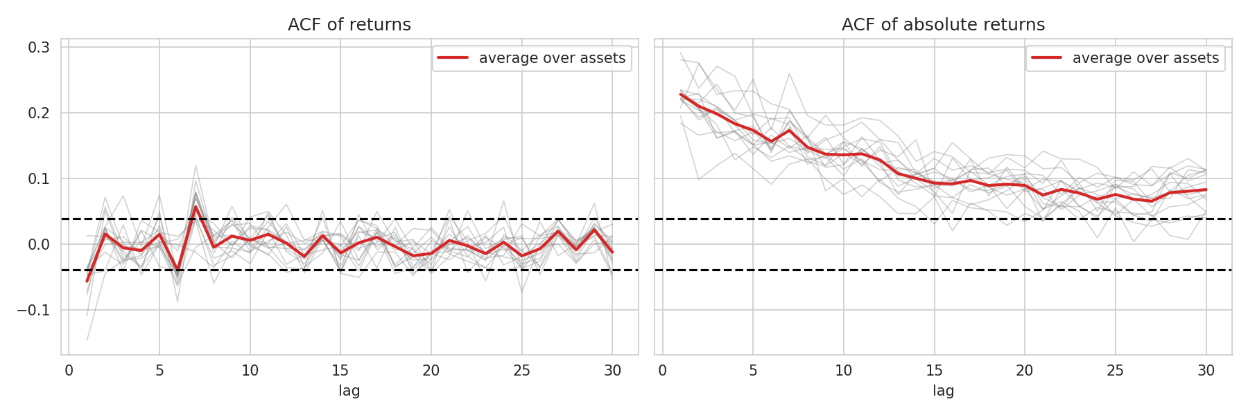

2.4 Volatility clustering
Figure 3 shows the returns of four representative stocks. Calm stretches alternate with bursts of large moves of both signs, notably in 2018 (truckers' strike and presidential election), in March 2020 and, for PETR4, around political and oil events. Together with the persistent autocorrelation of absolute returns and the ARCH-LM rejections, this is clear evidence of volatility clustering: returns are uncorrelated but not independent, so the series cannot be an iid sequence and the price cannot follow a geometric Brownian motion.
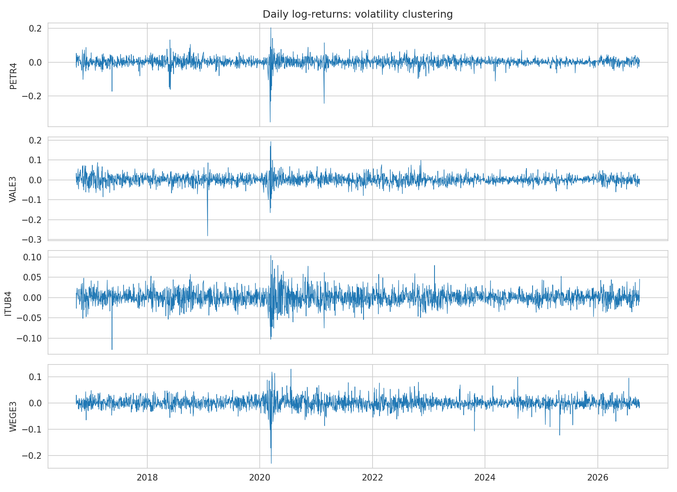

2.5 Correlation across assets
The average pairwise correlation of daily returns is 0.38 (range 0.16 to 0.83), and the first principal component of the correlation matrix explains 43% of total variance, which points to a strong common market factor.
- Highest correlations: the banks form a block: ITUB4-BBDC4 (0.83), ITUB4-BBAS3 (0.74), BBDC4-BBAS3 (0.72).
- Lowest correlations: VALE3-VIVT3 (0.16), VALE3-ENEV3 (0.19), GGBR4-VIVT3 (0.20).
Economic reading. Banks share the same exposure to interest rates, credit quality and the domestic cycle, so adding BBAS3 or BBDC4 to a portfolio holding ITUB4 brings little diversification. Exporters linked to commodities and to the exchange rate (VALE3, GGBR4) co-move little with domestic defensive and regulated names (telecoms, utilities), which are the best diversifiers in this sample.
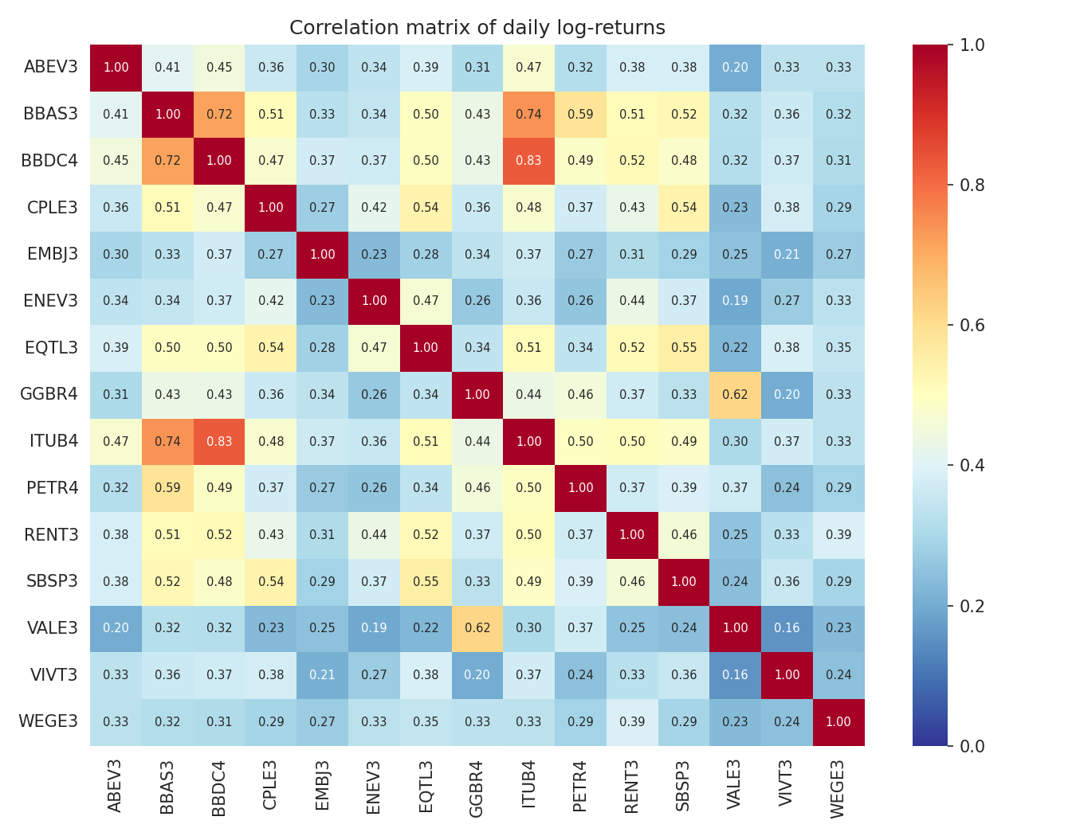

2.6 Are the moments constant over time?
We recompute the statistics on a rolling window of 250 days and by calendar year.
Year | Mean (%) | Ann. vol (%) | Skewness | Excess kurtosis | Avg pairwise correlation
2016 (from 26/09) | 0.047 | 39.1 | -0.50 | 1.77 | 0.33
2017 | 0.111 | 30.6 | -0.50 | 8.75 | 0.29
2018 | 0.072 | 33.0 | 0.03 | 1.75 | 0.34
2019 | 0.155 | 28.5 | -0.30 | 4.85 | 0.29
2020 | 0.015 | 57.5 | -0.71 | 7.25 | 0.59
2021 | 0.014 | 34.7 | 0.08 | 3.54 | 0.31
2022 | 0.035 | 33.9 | 0.12 | 5.02 | 0.28
2023 | 0.102 | 26.7 | 0.05 | 2.44 | 0.29
2024 | -0.013 | 25.2 | -0.20 | 5.64 | 0.21
2025 | 0.134 | 26.6 | -0.15 | 4.92 | 0.29
2026 (to 30/09) | 0.066 | 30.0 | 0.23 | 3.42 | 0.38
Table 4. Yearly statistics, averaged over the 15 assets. 2016 and 2026 are partial years.
- Mean: the rolling mean fluctuates around zero (Figure 5) and a test comparing the two halves of the sample does not reject equality for any of the 15 stocks. We find no evidence that the mean changes, although it is estimated with large noise.
- Variance: not constant. Average annualized volatility is 57.5% in 2020, against 25% to 39% in the other years, and Levene's test comparing the two halves of the sample rejects equal variances for 13 of 15 stocks (the exceptions are ENEV3 and RENT3).
- Skewness and kurtosis: not constant. Both jump in March 2020 (average rolling skewness close to -2 and average excess kurtosis of about 18, Figure 5) and then revert, which shows that sample skewness and kurtosis are driven by a few crisis days.
- Correlation: not constant. The average pairwise correlation rises from about 0.21 to 0.38 in normal years to 0.59 in 2020 (Figure 6), and ends the sample at 0.38 in 2026.
Economic reading. Risk is regime-dependent: in a crisis volatility roughly doubles, tails fatten and stocks move together, so the diversification benefit shrinks exactly when it is needed. A model with constant volatility and correlation, such as the normal variance-covariance method, would underestimate risk in turbulent periods and overstate it in calm ones.
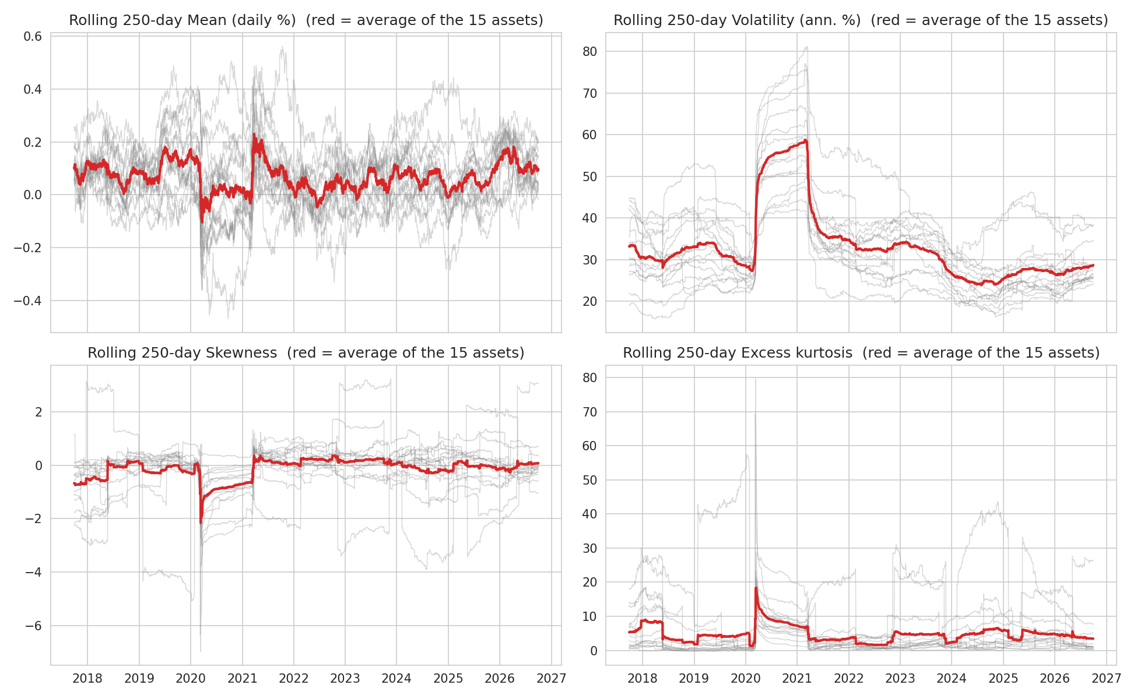
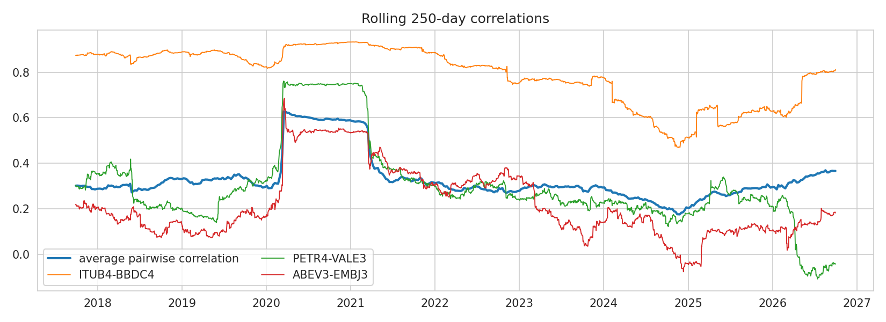

2.7 Conclusion of Question 2
The data show the stylized facts U1 to U6 and M1 to M4: returns are close to uncorrelated but not iid; absolute and squared returns are strongly autocorrelated; volatility varies over time and extreme returns cluster in crises; the distributions are skewed to the left and heavy-tailed; and cross-asset dependence increases in stress periods. Consequently, a model for the conditional variance (GARCH, Question 3) and a model for the tails (Student t and extreme value theory, Questions 4 to 7) are needed.

3. GARCH models and the portfolio (Question 3)

3.1 Gaussian GARCH(1,1) on each asset
Question 2 showed volatility clustering, so we model the conditional variance. For each series (script 03_garch_portfolio.py) we estimate, on the in-sample period 27/09/2016 to 30/09/2025 (2,237 returns, the last year being excluded), the model
r_t = mu + e_t, e_t = sigma_t z_t, z_t ~ N(0,1), sigma_t^2 = omega + alpha e_{t-1}^2 + beta sigma_{t-1}^2,
by Gaussian maximum likelihood (Python package arch, returns expressed in percent for numerical stability). We chose the GARCH(1,1) because it is the standard parsimonious benchmark, it is able to reproduce the autocorrelation of absolute returns documented in Question 2, and it keeps the number of parameters low. All estimations converged.
Series | alpha (p-value) | beta (p-value) | alpha + beta | omega (p-value)
ABEV3 | 0.101 (0.020) | 0.849 (0.000) | 0.951 | 0.143 (0.082)
BBAS3 | 0.098 (0.000) | 0.871 (0.000) | 0.969 | 0.171 (0.086)
BBDC4 | 0.154 (0.125) | 0.694 (0.001) | 0.848 | 0.688 (0.247)
CPLE3 | 0.110 (0.000) | 0.853 (0.000) | 0.963 | 0.158 (0.012)
EMBJ3 | 0.067 (0.105) | 0.905 (0.000) | 0.972 | 0.243 (0.188)
ENEV3 | 0.093 (0.061) | 0.822 (0.000) | 0.915 | 0.353 (0.378)
EQTL3 | 0.074 (0.000) | 0.878 (0.000) | 0.952 | 0.124 (0.009)
GGBR4 | 0.064 (0.086) | 0.900 (0.000) | 0.964 | 0.204 (0.322)
ITUB4 | 0.058 (0.000) | 0.920 (0.000) | 0.978 | 0.069 (0.041)
PETR4 | 0.154 (0.003) | 0.786 (0.000) | 0.940 | 0.436 (0.014)
RENT3 | 0.078 (0.000) | 0.872 (0.000) | 0.950 | 0.306 (0.000)
SBSP3 | 0.154 (0.008) | 0.721 (0.000) | 0.875 | 0.596 (0.118)
VALE3 | 0.052 (0.001) | 0.940 (0.000) | 0.992 | 0.057 (0.315)
VIVT3 | 0.049 (0.001) | 0.921 (0.000) | 0.970 | 0.076 (0.081)
WEGE3 | 0.084 (0.039) | 0.844 (0.000) | 0.927 | 0.306 (0.225)
PORT | 0.071 (0.000) | 0.902 (0.000) | 0.973 | 0.046 (0.005)
Table 5. Gaussian GARCH(1,1) estimates (returns in percent). The mean parameter mu is not shown (significant at 5% for 10 of 16 series).
Statistical reading.
- beta is significant at 1% for all 16 series, and alpha is significant at 5% for 12 of 16. For BBDC4 (p = 0.125), EMBJ3 (0.105), ENEV3 (0.061) and GGBR4 (0.086) the reaction to the latest shock is not significant, so volatility there is explained mostly by its own persistence.
- omega is significant for only 6 of 16 series. This is common when persistence is high: the intercept is weakly identified, whereas the implied long-run variance omega / (1 - alpha - beta) is well determined.
- Persistence (alpha + beta) is between 0.85 and 0.99, so all models are stationary but volatility shocks are long-lived. The implied half-life of a volatility shock is about 4 days for BBDC4 (0.848), 11 days for PETR4 (0.940), 31 days for ITUB4 (0.978) and 86 days for VALE3 (0.992), which is close to an integrated GARCH.
Economic reading. Brazilian large caps react strongly to news and then calm down slowly. The largest alpha (0.15) belongs to PETR4, BBDC4 and SBSP3, stocks exposed to political and regulatory news, whereas VALE3 and ITUB4 have low alpha and very high beta: their volatility moves slowly and is dominated by persistent regimes (commodity cycle, interest-rate cycle). In practice, after a crisis such as March 2020, risk estimates for these stocks stay high for months.

3.2 Portfolio weights and the portfolio PORT
We generated N = 15 values from a log-normal distribution (positive support, parameters 0 and 1) with a fixed seed (123, NumPy default_rng) and normalized them to sum to one. The weights are therefore reproducible: running the code again gives the same numbers.
ABEV3 | BBAS3 | BBDC4 | CPLE3 | EMBJ3 | ENEV3 | EQTL3 | GGBR4
1.71% | 3.18% | 16.68% | 5.58% | 11.55% | 8.19% | 2.43% | 7.91%

ITUB4 | PETR4 | RENT3 | SBSP3 | VALE3 | VIVT3 | WEGE3 | Sum
3.35% | 3.33% | 5.07% | 1.00% | 15.15% | 2.35% | 12.51% | 100%
Table 6. Portfolio weights (seed 123).
The four largest holdings (BBDC4, VALE3, WEGE3, EMBJ3) account for 56% of the portfolio. PORT is computed each day as the weighted average of the asset returns, r_PORT,t = sum_i w_i r_i,t, i.e. with constant weights (equivalent to a daily-rebalanced portfolio). Over the full sample PORT has an annualized volatility of 23.1%, against an average of 34.3% for the individual stocks, which is the diversification effect, but still a skewness of -1.33 and an excess kurtosis of 20 (dominated by March 2020), showing that diversification does not remove tail risk in a market-wide crash.
The Gaussian GARCH(1,1) of PORT (Table 5) has alpha = 0.071 and beta = 0.902, all significant at 1%, with persistence 0.973. The portfolio's volatility is more persistent than that of most single stocks, because it aggregates the common market factor and averages out idiosyncratic shocks.

3.3 Conditional variance
Figure 7 plots the in-sample conditional variances of PETR4, ITUB4, VALE3 and PORT. All series peak in March 2020: the conditional volatility reaches 15.1% per day for PETR4 (16/03/2020), 8.2% for VALE3 (17/03/2020), 5.2% for ITUB4 (25/03/2020) and 7.7% for PORT (19/03/2020), against a PORT median of 1.2%, i.e. about six times higher. The variance then decays gradually, in line with the persistence estimated above, and stays low from 2023 to 2025 (PORT daily volatility 0.85% on 30/09/2025). This is exactly the time-varying risk that a constant-variance model would miss.
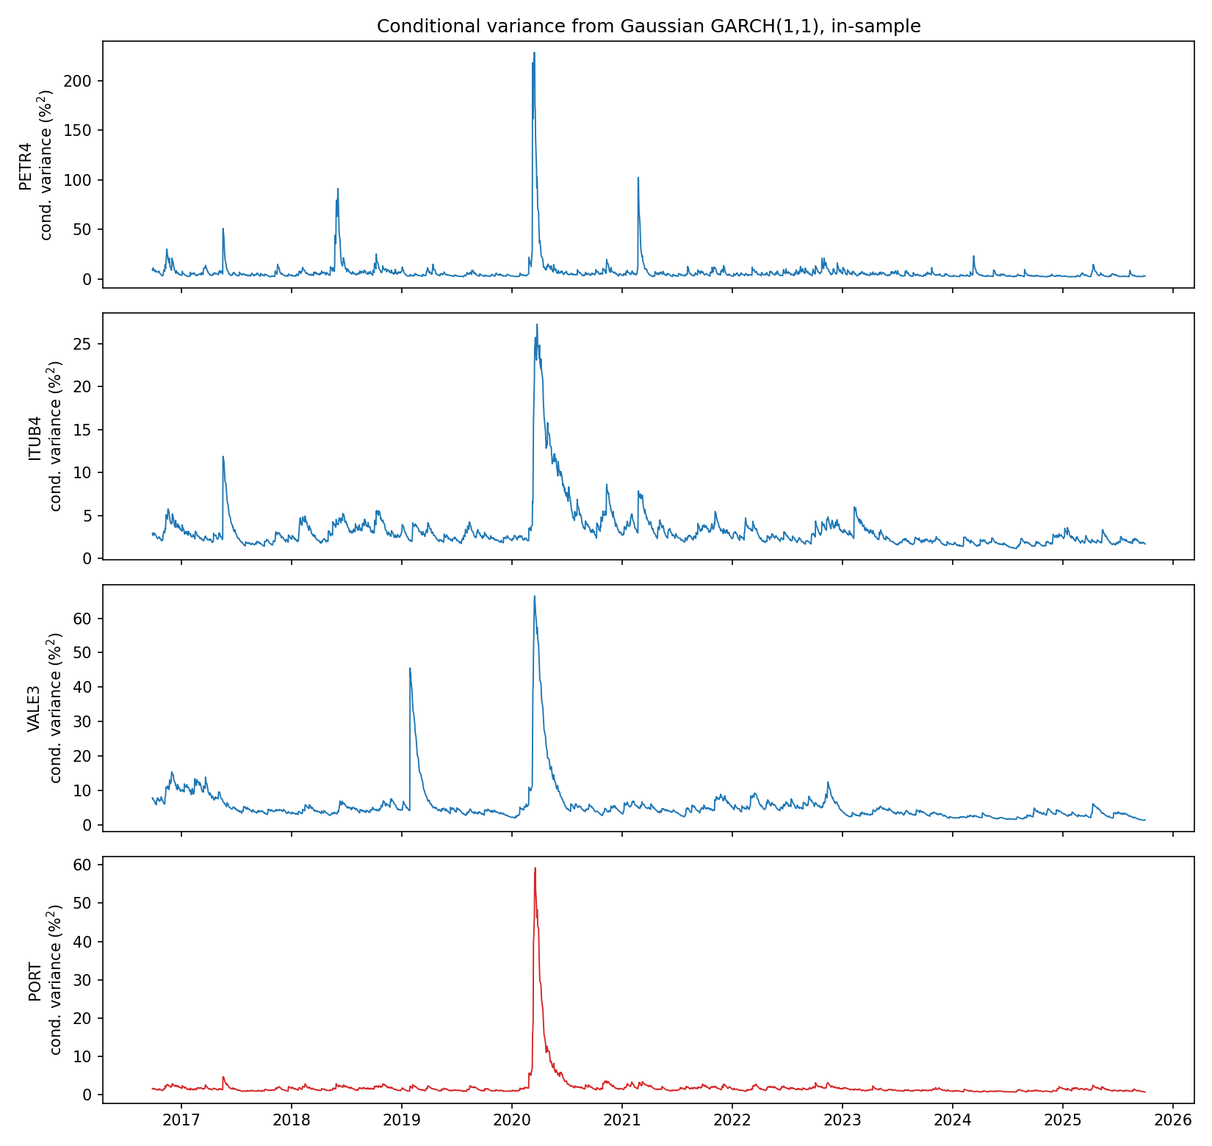

4. VaR with GARCH forecasts (Question 4)

4.1 Forecasting scheme and VaR Case 1 (Normal)
The last year (01/10/2025 to 30/09/2026, 249 trading days) is used for out-of-sample evaluation (script 04_var_garch.py). For each series we produce one-step-ahead forecasts of the mean and variance with an expanding window, re-estimating the parameters every 20 trading days (13 estimations) and updating the variance recursion each day with the realized return. We use the convention that a loss is L = -r, the VaR is a positive number, and a violation occurs when the return is below minus the VaR. Levels are 95% and 99%. Under normality,
VaR_t(alpha) = -mu_t + sigma_t Phi^{-1}(alpha) (VaR Case 1).

4.2 Are the standardized residuals normal?
Z are the in-sample standardized residuals of the Gaussian GARCH, z_t = (r_t - mu) / sigma_t.
Series | Skewness | Excess kurtosis | Jarque-Bera p | Anderson-Darling | KS p (vs N(0,1)) | t df fitted on Z
ABEV3 | 0.04 | 4.42 | 0.000 | 13.25 | 0.000 | 4.4
BBAS3 | -0.83 | 8.76 | 0.000 | 11.97 | 0.000 | 5.0
BBDC4 | -0.42 | 8.47 | 0.000 | 13.35 | 0.000 | 4.8
CPLE3 | 0.12 | 2.83 | 0.000 | 5.93 | 0.000 | 6.6
EMBJ3 | 0.53 | 10.70 | 0.000 | 20.45 | 0.000 | 4.1
ENEV3 | 0.40 | 4.89 | 0.000 | 10.07 | 0.000 | 5.2
EQTL3 | 0.15 | 1.02 | 0.000 | 2.10 | 0.056 | 10.4
GGBR4 | 0.01 | 1.56 | 0.000 | 5.19 | 0.004 | 6.9
ITUB4 | -0.15 | 3.06 | 0.000 | 3.75 | 0.031 | 7.7
PETR4 | -0.65 | 4.91 | 0.000 | 14.88 | 0.000 | 4.3
RENT3 | -0.04 | 2.25 | 0.000 | 5.81 | 0.000 | 6.5
SBSP3 | 0.13 | 2.33 | 0.000 | 6.91 | 0.007 | 5.7
VALE3 | -1.09 | 16.78 | 0.000 | 11.44 | 0.000 | 5.3
VIVT3 | -0.01 | 2.36 | 0.000 | 9.45 | 0.000 | 5.0
WEGE3 | 0.04 | 3.72 | 0.001 | 10.45 | 0.001 | 4.9
PORT | -0.31 | 1.48 | 0.000 | 2.62 | 0.079 | 9.3
Table 7. Normality of the in-sample standardized residuals Z (Anderson-Darling 1% critical value: 1.035).
Statistical reading. The Jarque-Bera test rejects normality for all 16 series, the Anderson-Darling statistic exceeds the 1% critical value for all 16, and the Kolmogorov-Smirnov test rejects for 14 of 16 (not for EQTL3 and PORT). The GARCH filter removes a large part of the excess kurtosis (median of about 10.6 for the raw returns down to about 3.4 for Z) but not all of it. The skewness of Z has mixed signs (from -1.09 for VALE3 to +0.53 for EMBJ3), so what remains is mainly a symmetric heavy-tail problem, not an asymmetry problem.

4.3 Alternative density and VaR Case 2
We re-estimated each GARCH(1,1) with four innovation densities (Normal, Student t, Hansen skew-t, generalized error distribution) and compared them with the BIC and AIC.
- The Student t is selected: it has the lowest BIC for 15 of 16 series (skew-t wins only for EMBJ3, by 0.8 points). BIC gains over the Normal are large for single stocks (for example 279 points for PETR4, 419 for EMBJ3, 270 for VALE3) and smaller for the portfolio (53 points) and EQTL3 (34 points). The skew-t does not improve on the t because the skewness of Z is small and of mixed sign; the GED fits worse than the t.
- Degrees of freedom: fitted on Z, the t has between 4.1 (EMBJ3) and 10.4 (EQTL3) degrees of freedom (9.3 for PORT), i.e. heavy tails for single stocks and a tail closer to normal for the diversified portfolio.
VaR Case 2 replaces the normal quantile with the quantile of the unit-variance Student t estimated for each series (re-estimated every 20 days like the other parameters).
Series | Mean VaR 99% Normal (%) | Mean VaR 99% t (%) | Violations Normal | Violations t
ABEV3 | 3.59 | 4.13 | 0 | 0
BBAS3 | 4.39 | 4.82 | 1 | 1
BBDC4 | 4.25 | 4.56 | 2 | 2
CPLE3 | 3.87 | 4.25 | 2 | 1
EMBJ3 | 5.75 | 6.49 | 6 | 5
ENEV3 | 4.71 | 5.37 | 2 | 1
EQTL3 | 3.62 | 3.85 | 4 | 3
GGBR4 | 4.51 | 4.80 | 4 | 2
ITUB4 | 3.55 | 3.82 | 1 | 1
PETR4 | 4.43 | 4.89 | 2 | 1
RENT3 | 5.48 | 6.04 | 3 | 3
SBSP3 | 4.35 | 4.80 | 3 | 2
VALE3 | 4.01 | 4.52 | 2 | 2
VIVT3 | 3.67 | 4.16 | 6 | 4
WEGE3 | 4.36 | 4.91 | 4 | 3
PORT | 2.70 | 2.87 | 5 | 5
Total (expected 39.8) |  |  | 47 | 36
Table 8. 99% VaR (average over the 249 out-of-sample days) and number of violations, Cases 1 and 2. About 2.5 violations per series are expected.
What happens to the VaR when normality is replaced by the t?
- At 99%, the VaR increases by 6% (PORT) to 15% (ABEV3), on average from 4.20% to 4.64% (+10%), because the t puts more probability in the far tail. The total number of violations falls from 47 to 36, closer to the 39.8 expected, and the series with too many violations under the Normal improve (GGBR4 4 to 2, VIVT3 6 to 4, EQTL3 4 to 3).
- At 95%, the VaR decreases on average from 2.94% to 2.79% (-5%), because a unit-variance t has more mass near the centre and fewer moderate shocks than the normal. Violations rise from 175 to 188 (expected 199), so the Normal VaR was somewhat conservative at this level.
Economic reading. The Normal model understates the risk of rare large losses (99%) and overstates the risk of ordinary bad days (95%). For a bank or insurer this implies that regulatory-type levels (99% and beyond) based on the normal distribution would produce too little capital, while risk limits at 95% would be slightly too tight. A fat-tailed distribution corrects both, at the price of about 10% more capital at the 99% level.

5. Extreme value theory: GEV (Question 5)

5.1 Method
We work on the in-sample standardized residuals Z (2,237 observations) turned into losses, L = -Z (script 05_gev.py). Positive values of L are bad days.
- Block maxima: we split the sample into blocks of m = 21 trading days (about one month) and take the maximum loss of each block, which gives 106 block maxima per series. The block length is a trade-off: longer blocks make the GEV approximation better but leave fewer maxima.
- GEV under independence: a GEV(xi, mu, sigma) is fitted by maximum likelihood, assuming iid losses, so that the distribution of the block maximum is H(x) = F(x)^m. The shape xi measures tail heaviness (xi > 0: heavy, power-law tail; xi = 0: Gumbel; xi < 0: bounded tail).
- Quality of the fit: (i) normal-approximation standard errors from the numerical Hessian; (ii) a likelihood-ratio test of the Gumbel restriction xi = 0; (iii) Kolmogorov-Smirnov and Anderson-Darling statistics with parametric-bootstrap p-values (200 replications, since the parameters are estimated and the standard KS table would be too permissive); (iv) Q-Q plots of the block maxima against the fitted GEV.

5.2 Results of the fit
Series | xi (s.e.) | mu | sigma | LR test xi = 0 (p) | KS p (bootstrap) | AD p (bootstrap)
ABEV3 | 0.085 (0.062) | 1.571 | 0.672 | 0.136 | 0.025 | 0.040
BBAS3 | 0.254 (0.073) | 1.479 | 0.595 | 0.000 | 0.555 | 0.525
BBDC4 | 0.239 (0.074) | 1.433 | 0.649 | 0.000 | 0.680 | 0.725
CPLE3 | 0.131 (0.066) | 1.576 | 0.521 | 0.024 | 0.085 | 0.045
EMBJ3 | 0.143 (0.062) | 1.459 | 0.600 | 0.005 | 0.180 | 0.110
ENEV3 | 0.204 (0.091) | 1.490 | 0.530 | 0.011 | 0.600 | 0.600
EQTL3 | 0.057 (0.078) | 1.585 | 0.472 | 0.450 | 0.780 | 0.865
GGBR4 | 0.064 (0.073) | 1.633 | 0.545 | 0.352 | 0.070 | 0.065
ITUB4 | 0.112 (0.062) | 1.478 | 0.541 | 0.026 | 0.990 | 0.805
PETR4 | 0.180 (0.076) | 1.664 | 0.687 | 0.005 | 0.425 | 0.655
RENT3 | 0.265 (0.088) | 1.511 | 0.454 | 0.000 | 0.305 | 0.340
SBSP3 | 0.136 (0.098) | 1.574 | 0.535 | 0.126 | 0.560 | 0.160
VALE3 | 0.158 (0.060) | 1.498 | 0.593 | 0.000 | 0.795 | 0.330
VIVT3 | 0.081 (0.070) | 1.676 | 0.563 | 0.210 | 0.525 | 0.560
WEGE3 | 0.160 (0.068) | 1.491 | 0.595 | 0.008 | 0.225 | 0.520
PORT | 0.077 (0.068) | 1.676 | 0.575 | 0.216 | 0.645 | 0.710
Table 9. GEV fit to the block maxima (m = 21) of the standardized losses, and quality of the fit.
Statistical reading.
- Heavy tails: the estimated shape is positive for all 16 series, between 0.057 (EQTL3) and 0.265 (RENT3), i.e. Frechet-type tails. A shape of 0.18 (PETR4) corresponds to a tail index 1/xi of about 5.6, so moments of order higher than about five do not exist. The likelihood-ratio test rejects the Gumbel restriction xi = 0 at 5% for 10 of 16 series; for the remaining six (ABEV3, EQTL3, GGBR4, SBSP3, VIVT3 and PORT) a thin exponential tail cannot be excluded, but the standard errors (0.06 to 0.10) are large because only 106 maxima are available.
- Quality of the fit: the bootstrap Kolmogorov-Smirnov test rejects the GEV at 5% for one series (ABEV3) and the Anderson-Darling test for two (ABEV3 and CPLE3). With 32 tests, about 1.6 rejections would be expected by chance, so the fit is satisfactory. In the Q-Q plots (Figure 8) the bulk of the maxima lies on the diagonal for all series; the deviations are confined to the one or two largest maxima, which lie above the fitted line (most visibly VALE3, ITUB4 and EMBJ3), so the fitted GEV may slightly underestimate the most extreme blocks, typically March 2020.
Economic reading. The heaviest tails belong to RENT3 (a cyclical, leveraged consumer-credit-sensitive business) and to the banks BBAS3 and BBDC4 (exposed to credit quality, interest rates and political risk to the state bank), while the lightest tails are found for EQTL3 (regulated utility), GGBR4, VIVT3 and the diversified PORT. Diversification and regulation therefore reduce, but do not remove, extreme residual risk.
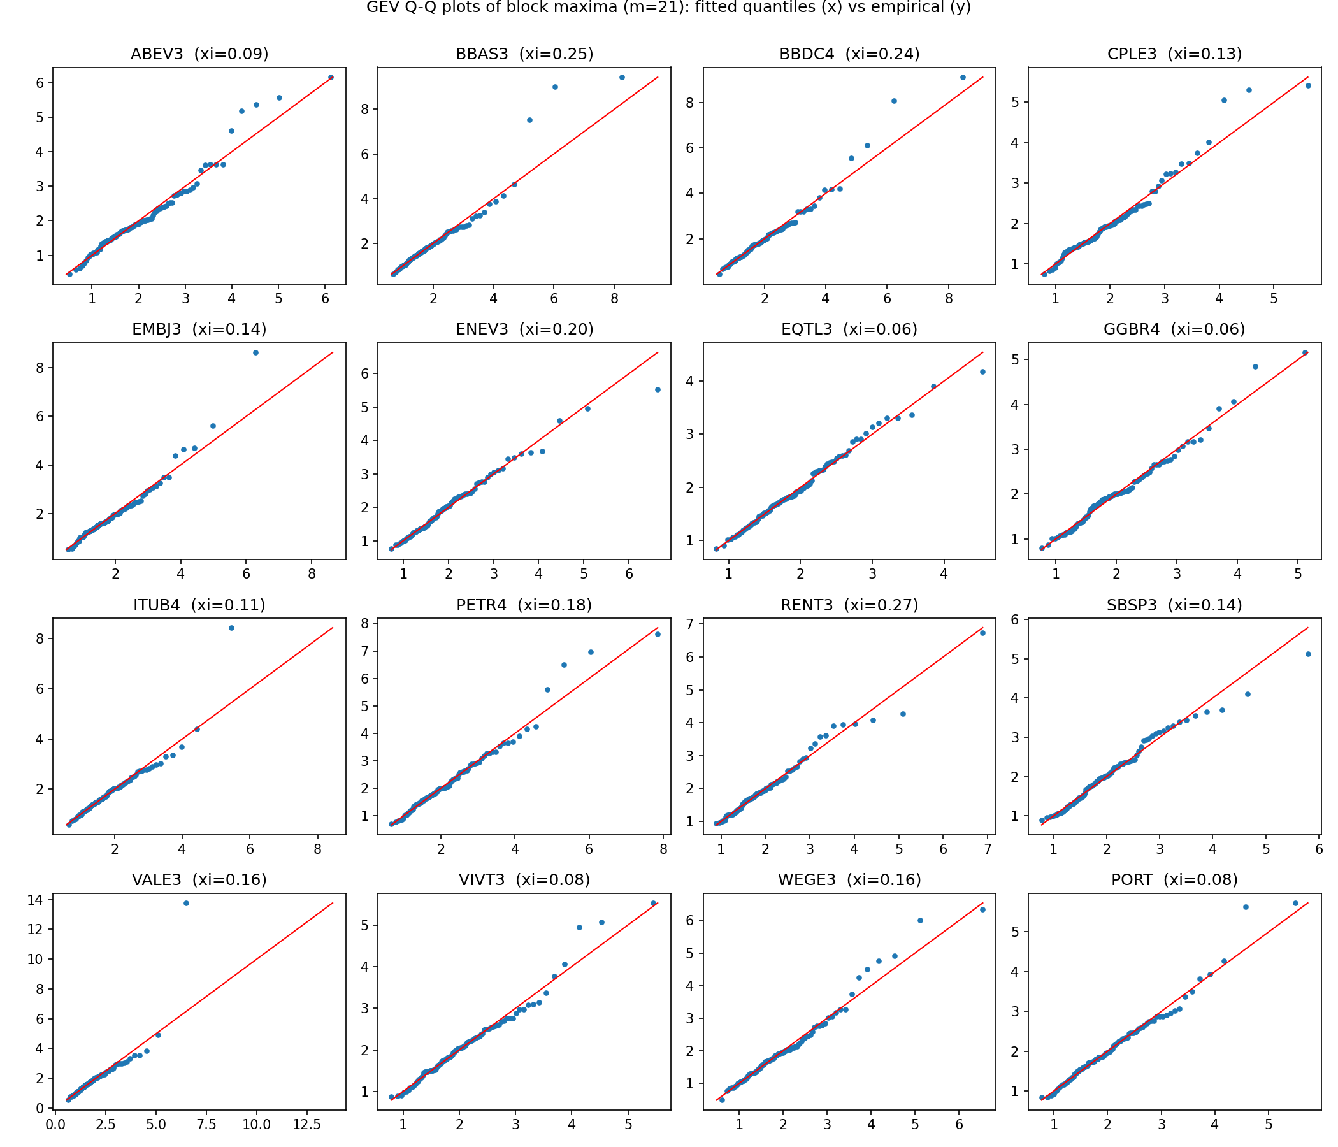

5.3 Extremal index
The extremal index theta in (0, 1] measures the clustering of extremes: 1/theta is the mean size of a cluster of exceedances, and theta = 1 means that extremes occur in isolation. We estimate it with the intervals estimator of Ferro and Segers (2003), with the threshold at the 95% quantile of the losses (runs estimator with run length 5 and other thresholds are reported as sensitivity checks in table_extremal_index.csv; the runs estimator gives lower values and is sensitive to the run length, so we do not use it for the VaR).
Series | theta | Series | theta
ABEV3 | 0.985 | GGBR4 | 0.996
BBAS3 | 0.919 | ITUB4 | 0.901
BBDC4 | 0.934 | PETR4 | 1.000
CPLE3 | 1.000 | RENT3 | 0.892
EMBJ3 | 0.924 | SBSP3 | 0.772
ENEV3 | 0.688 | VALE3 | 0.956
EQTL3 | 1.000 | VIVT3 | 0.973
WEGE3 | 0.830 | PORT | 1.000
Table 10. Extremal index (intervals estimator, threshold at the 95% quantile of the losses).
The estimates are close to one for most series, i.e. after filtering with the GARCH model the extreme standardized losses are mostly isolated. The clustering of extremes seen in the raw returns in Question 2 is therefore largely explained by time-varying volatility. The remaining clustering is concentrated in ENEV3 (theta = 0.69, clusters of about 1.5 exceedances), SBSP3 (0.77) and WEGE3 (0.83); for PETR4, CPLE3, EQTL3 and PORT, theta equals one.

5.4 Value-at-Risk of Z with and without the extremal index
The VaR of Z at level alpha is the alpha-quantile of the loss distribution F. Since the distribution of the block maximum is H(x) = F(x)^(m theta), solving F(x) = alpha gives
- without extremal index (independence, theta = 1): VaR_alpha(Z) = H^{-1}(alpha^m);
- with extremal index: VaR_alpha(Z) = H^{-1}(alpha^(m theta)).
Series | Normal | Empirical | GEV, independence | GEV, extremal index | theta
ABEV3 | 2.326 | 2.521 | 2.689 | 2.700 | 0.985
BBAS3 | 2.326 | 2.534 | 2.614 | 2.689 | 0.919
BBDC4 | 2.326 | 2.494 | 2.655 | 2.719 | 0.934
CPLE3 | 2.326 | 2.392 | 2.475 | 2.475 | 1.000
EMBJ3 | 2.326 | 2.353 | 2.505 | 2.565 | 0.924
ENEV3 | 2.326 | 2.428 | 2.461 | 2.743 | 0.688
EQTL3 | 2.326 | 2.455 | 2.353 | 2.353 | 1.000
GGBR4 | 2.326 | 2.459 | 2.524 | 2.526 | 0.996
ITUB4 | 2.326 | 2.469 | 2.398 | 2.465 | 0.901
PETR4 | 2.326 | 2.900 | 2.896 | 2.896 | 1.000
RENT3 | 2.326 | 2.461 | 2.386 | 2.466 | 0.892
SBSP3 | 2.326 | 2.553 | 2.501 | 2.675 | 0.772
VALE3 | 2.326 | 2.441 | 2.543 | 2.577 | 0.956
VIVT3 | 2.326 | 2.557 | 2.609 | 2.627 | 0.973
WEGE3 | 2.326 | 2.434 | 2.543 | 2.687 | 0.830
PORT | 2.326 | 2.572 | 2.627 | 2.627 | 1.000
Table 11. 99% VaR of the standardized losses Z (a loss quantile in units of standard deviation).
Statistical reading.
- 99% level: the GEV quantile exceeds the normal value of 2.326 for all 16 series (2.35 to 2.90). PETR4 is the most extreme, about 25% above the normal quantile. The GEV values are broadly in line with the empirical quantiles, which rest on only about 22 observations beyond the 99% level and are therefore noisy; EVT smooths them using the whole tail.
- Effect of the extremal index: when theta < 1 the VaR increases (ENEV3 from 2.46 to 2.74, SBSP3 from 2.50 to 2.68, WEGE3 from 2.54 to 2.69), and it is unchanged where theta = 1. The intuition: with clustering, a block contains fewer independent extremes, so observed block maxima are smaller than iid data with the same marginal distribution would produce. Ignoring clustering therefore underestimates the marginal tail and the VaR.
- 95% level: the GEV quantiles (1.39 to 1.63) are below the normal value of 1.645, as are the empirical ones (1.47 to 1.62). EVT is useful to describe the far tail, but at 95% the standardized residuals are more concentrated than a normal, in line with what we found for the t distribution in Question 4.
Economic reading. If the portfolio manager used the normal quantile (2.33) to scale the GARCH volatility at the 99% level, the risk of PETR4 would be understated by roughly one fifth, and that of stocks with clustered extremes (ENEV3, SBSP3, WEGE3) by 6% to 11% if clustering were ignored. In other words, tail risk is stock-specific and should not be summarized by a single multiplier.

6. Extreme value theory: GPD (Question 6)

6.1 Method
We repeat the analysis with the peaks-over-threshold method (script 06_gpd.py): exceedances of the standardized losses over a high threshold u are modelled with a generalized Pareto distribution GPD(xi, beta).
- Threshold: u is the 90% quantile of the losses (224 exceedances per series). We did not use the 95% quantile because then the 95% VaR would coincide with the threshold by construction. The mean-excess functions and the stability of xi as a function of the threshold are shown in Figure 9, and a sensitivity analysis over thresholds from the 85% to the 95% quantile is saved in table_gpd_threshold_sensitivity.csv: the 99% VaR of Z changes by at most about 0.2 across thresholds, whereas xi is less stable.
- VaR and ES of Z: VaR_alpha = u + (beta / xi) [ ((n / N_u)(1 - alpha))^(-xi) - 1 ], and ES_alpha = VaR_alpha / (1 - xi) + (beta - xi u) / (1 - xi), where n is the sample size and N_u the number of exceedances.
- Extremal index: in the peaks-over-threshold method the marginal tail is estimated from all exceedances, so the extremal index does not change the VaR point estimate (it affects only its uncertainty). Hence there is a single VaR under the GPD, which corresponds to the independence case used in Case 5 of Question 7. This is a difference with the block-maxima approach of Question 5.
- Quality of the fit: same tools as for the GEV (standard errors, likelihood-ratio test of xi = 0, bootstrap KS and AD tests, Q-Q plots).

6.2 Results
Series | xi (s.e.) | beta | LR xi = 0 (p) | KS p | AD p | VaR 99% of Z | ES 99% of Z
ABEV3 | 0.126 (0.068) | 0.548 | 0.030 | 0.100 | 0.035 | 2.632 | 3.469
BBAS3 | 0.239 (0.075) | 0.500 | 0.000 | 0.390 | 0.370 | 2.655 | 3.796
BBDC4 | 0.268 (0.080) | 0.478 | 0.000 | 0.440 | 0.815 | 2.636 | 3.849
CPLE3 | 0.144 (0.074) | 0.474 | 0.022 | 0.955 | 0.975 | 2.469 | 3.242
EMBJ3 | 0.161 (0.069) | 0.512 | 0.003 | 0.715 | 0.405 | 2.506 | 3.390
ENEV3 | 0.141 (0.078) | 0.484 | 0.036 | 0.625 | 0.665 | 2.497 | 3.276
EQTL3 | 0.036 (0.077) | 0.487 | 0.628 | 0.850 | 0.575 | 2.396 | 2.945
GGBR4 | 0.023 (0.065) | 0.592 | 0.721 | 0.270 | 0.320 | 2.569 | 3.207
ITUB4 | 0.150 (0.071) | 0.457 | 0.006 | 0.950 | 0.880 | 2.472 | 3.232
PETR4 | 0.246 (0.089) | 0.564 | 0.000 | 0.610 | 0.385 | 2.874 | 4.191
RENT3 | 0.175 (0.078) | 0.461 | 0.006 | 0.630 | 0.195 | 2.520 | 3.357
SBSP3 | -0.021 (0.067) | 0.649 | 0.754 | 0.940 | 0.755 | 2.609 | 3.214
VALE3 | 0.171 (0.064) | 0.509 | 0.000 | 0.005 | 0.135 | 2.541 | 3.451
VIVT3 | 0.038 (0.066) | 0.612 | 0.547 | 0.165 | 0.480 | 2.641 | 3.335
WEGE3 | 0.146 (0.069) | 0.531 | 0.012 | 0.110 | 0.025 | 2.554 | 3.423
PORT | 0.043 (0.062) | 0.598 | 0.460 | 0.020 | 0.025 | 2.669 | 3.358
Table 12. GPD fit above the 90% quantile of the standardized losses (224 exceedances), VaR and Expected Shortfall of Z at 99%.
Statistical reading.
- Shape: xi is positive for 15 of 16 series (0.023 to 0.268); only SBSP3 is slightly negative (-0.021), and not significantly different from zero. The largest values are for BBDC4 (0.268), PETR4 (0.246) and BBAS3 (0.239), in line with the GEV ranking. The likelihood-ratio test rejects the exponential tail (xi = 0) for 11 of 16 series.
- Quality of the fit: the bootstrap tests reject the GPD at 5% for 2 series by Kolmogorov-Smirnov (VALE3 and PORT) and for 3 by Anderson-Darling (ABEV3, WEGE3 and PORT), so the fit is acceptable for 13 or more series, with some doubts for PORT.
- VaR 99%: between 2.40 (EQTL3) and 2.87 (PETR4), above the normal 2.326 for every series, and close to the GEV values (differences from 0.01 to 0.13, the largest being RENT3 with 2.52 for the GPD against 2.39 for the GEV). At 95% the GPD VaR lies between 1.45 and 1.64, below the normal 1.645, as for the GEV.
- Expected Shortfall: the ES at 99% of Z is between 2.95 (EQTL3) and 4.19 (PETR4), against 2.67 under normality; at 95% it ranges from 2.09 to 2.44, against 2.06. The ES-to-VaR ratio is therefore much higher than under normality for heavy-tailed stocks, which is the signature of heavy tails.
Comparison GEV and GPD. The two methods agree on the ranking and the order of magnitude of tail risk. The GPD uses more data (224 exceedances against 106 block maxima) and is more efficient; the GEV is more robust when extremes are dependent and allows an explicit treatment of the extremal index. We therefore use both in the VaR evaluation of Question 7.
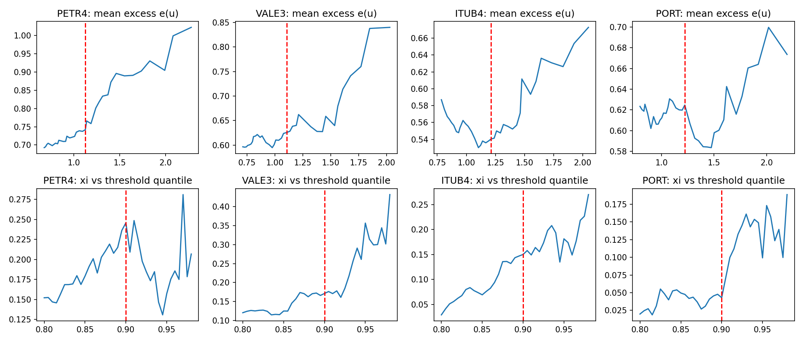

7. VaR of the returns with GARCH and EVT (Question 7)

7.1 Construction
The EVT quantiles of Question 5 and Question 6 refer to the standardized losses -Z, so they must be rescaled with the GARCH forecasts of the mean and the volatility (script 07_var_evt.py). Since r_t = mu_t + sigma_t Z_t, the loss is L_t = -mu_t + sigma_t (-Z_t) and
VaR_t(alpha) = -mu_t + sigma_t q(alpha),
where mu_t and sigma_t are the one-step-ahead forecasts of Question 4 (Gaussian GARCH, parameters re-estimated every 20 days) and q(alpha) is the in-sample EVT quantile of the standardized loss, estimated once on the in-sample period and not re-estimated when new data arrive, as required. The three cases are:
- Case 3: q(alpha) from the GEV under independence (Table 11, column "GEV, independence");
- Case 4: q(alpha) from the GEV with the extremal index (Table 11, column "GEV, extremal index");
- Case 5: q(alpha) from the GPD (Table 12).

7.2 Results
Series | Case 1 Normal | Case 2 t | Case 3 GEV | Case 4 GEV with theta | Case 5 GPD
ABEV3 | 3.59 | 4.12 | 4.15 | 4.17 | 4.06
BBAS3 | 4.39 | 4.82 | 4.94 | 5.08 | 5.02
BBDC4 | 4.25 | 4.56 | 4.87 | 4.99 | 4.83
CPLE3 | 3.87 | 4.25 | 4.12 | 4.12 | 4.11
EMBJ3 | 5.74 | 6.49 | 6.20 | 6.35 | 6.20
ENEV3 | 4.71 | 5.36 | 4.99 | 5.57 | 5.06
EQTL3 | 3.62 | 3.85 | 3.66 | 3.66 | 3.73
GGBR4 | 4.50 | 4.80 | 4.89 | 4.90 | 4.98
ITUB4 | 3.55 | 3.82 | 3.66 | 3.76 | 3.77
PETR4 | 4.43 | 4.89 | 5.55 | 5.55 | 5.51
RENT3 | 5.48 | 6.04 | 5.63 | 5.82 | 5.95
SBSP3 | 4.35 | 4.80 | 4.68 | 5.02 | 4.89
VALE3 | 4.01 | 4.52 | 4.39 | 4.45 | 4.38
VIVT3 | 3.67 | 4.16 | 4.13 | 4.16 | 4.18
WEGE3 | 4.36 | 4.91 | 4.78 | 5.05 | 4.80
PORT | 2.70 | 2.86 | 3.06 | 3.06 | 3.11
Table 13. Average 99% VaR (percent of the position per day) over the 249 out-of-sample days, for the five cases.
- Level: the EVT-based VaR is above the Normal VaR for every series, by about 10% on average (4.20% for the Normal against 4.61%, 4.73% and 4.66% for Cases 3, 4 and 5). The increase is largest for PETR4 (5.55% against 4.43%, +25%) and PORT (about +13% to +15%), whose standardized tails are heaviest relative to a normal.
- Case 4 against Case 3: the two coincide where theta = 1 (CPLE3, EQTL3, PETR4, PORT) and differ where clustering is detected: the extremal index raises the VaR, by 12% for ENEV3 (4.99% to 5.57%), 7% for SBSP3, 6% for WEGE3 and 2% to 4% for most other series.
- Case 5 against Case 3: the GPD and GEV VaR are very close for most series (typical differences below 0.15 percentage points), with larger gaps for RENT3 (5.95% against 5.63%) and ENEV3, reflecting the differences in the estimated tail quantiles seen in Questions 5 and 6.
- Dynamics: all VaR sequences move together with the GARCH volatility forecast, and the EVT cases are essentially a rescaling of the same volatility path (Figure 10), so the difference between cases is mainly a difference in the level of the multiplier q(alpha).

8. Comparison of the VaR sequences (Question 8)
We contrast the five VaR sequences out of sample (script 08_var_comparison.py) using, for all 16 series, the number of days on which the return is below minus the VaR, formal backtests, the average VaR level, and the quantile (check) loss. The graphs focus on PETR4, as an example of a heavy-tailed single stock, and PORT. About 2.5 violations per series are expected at 99% (12.5 at 95%) over 249 days.

8.1 Number of violations
Case | Total violations 99% | Kupiec rejections 99% | Total violations 95% | Kupiec rejections 95%
Expected | 39.8 |  | 199.2
Case 1: Normal | 47 | 1 | 175 | 2
Case 2: t | 36 | 1 | 188 | 1
Case 3: GEV, independence | 35 | 1 | 211 | 1
Case 4: GEV, extremal index | 35 | 1 | 197 | 1
Case 5: GPD | 34 | 1 | 200 | 1
Table 14. Violations summed over the 16 series and number of series for which the Kupiec test rejects correct coverage at 5%.
Series | Case 1 | Case 2 | Case 3 | Case 4 | Case 5
ABEV3 | 0 | 0 | 0 | 0 | 0
BBAS3 | 1 | 1 | 1 | 1 | 1
BBDC4 | 2 | 2 | 2 | 2 | 2
CPLE3 | 2 | 1 | 1 | 1 | 1
EMBJ3 | 6 | 5 | 5 | 5 | 5
ENEV3 | 2 | 1 | 1 | 1 | 1
EQTL3 | 4 | 3 | 4 | 4 | 3
GGBR4 | 4 | 2 | 2 | 2 | 2
ITUB4 | 1 | 1 | 1 | 1 | 1
PETR4 | 2 | 1 | 1 | 1 | 1
RENT3 | 3 | 3 | 3 | 3 | 3
SBSP3 | 3 | 2 | 2 | 2 | 2
VALE3 | 2 | 2 | 2 | 2 | 2
VIVT3 | 6 | 4 | 4 | 4 | 4
WEGE3 | 4 | 3 | 3 | 3 | 3
PORT | 5 | 5 | 3 | 3 | 3
Table 15. Number of days with a return below minus the 99% VaR, by series and case (about 2.5 expected).
Statistical reading.
- 99% level: the Normal VaR is violated more often than expected (47 against 39.8), and the five alternatives are slightly conservative (34 to 36). For the two series in focus, PETR4 has 2 violations under the Normal and 1 in all other cases, and PORT has 5 under the Normal and the t but only 3 under the three EVT cases.
- Formal tests at 99%: the Kupiec test rejects correct coverage in one series for every case, always ABEV3, which has no violation at all (2.5 expected): the VaR is too conservative there, not too low. The Christoffersen independence test does not reject for any series, and the conditional-coverage test rejects only for EMBJ3 under the Normal (p = 0.0498, borderline, 6 violations).
- 95% level: the Normal VaR gives the fewest violations (175 against 199.2 expected), because the Normal quantile (1.645) is higher than the empirical 95% quantile of Z (Question 5). The GEV under independence gives the most (211), the GEV with the extremal index and the GPD are the closest to the target (197 and 200). The Kupiec test rejects for ABEV3 in all cases (5 or 6 violations against 12.5 expected) and for WEGE3 under the Normal; the conditional-coverage test rejects for ABEV3 and, under Cases 3 to 5, for EQTL3 (and ITUB4 under Case 3), which show 19 violations against 12.5 expected.
- Quantile loss: the average check loss is almost identical across cases (about 0.060 to 0.061 at 99% and 0.197 to 0.199 at 95%, in percent), so no case dominates on this criterion.
Caution. With 249 days and about 2.5 expected violations per series at 99%, the tests have little power: a non-rejection does not prove that a model is correct, and differences of one or two violations are within sampling noise. The evidence is stronger when aggregated over the 16 series (47 against 34 to 36).

8.2 Level and timing of the VaR
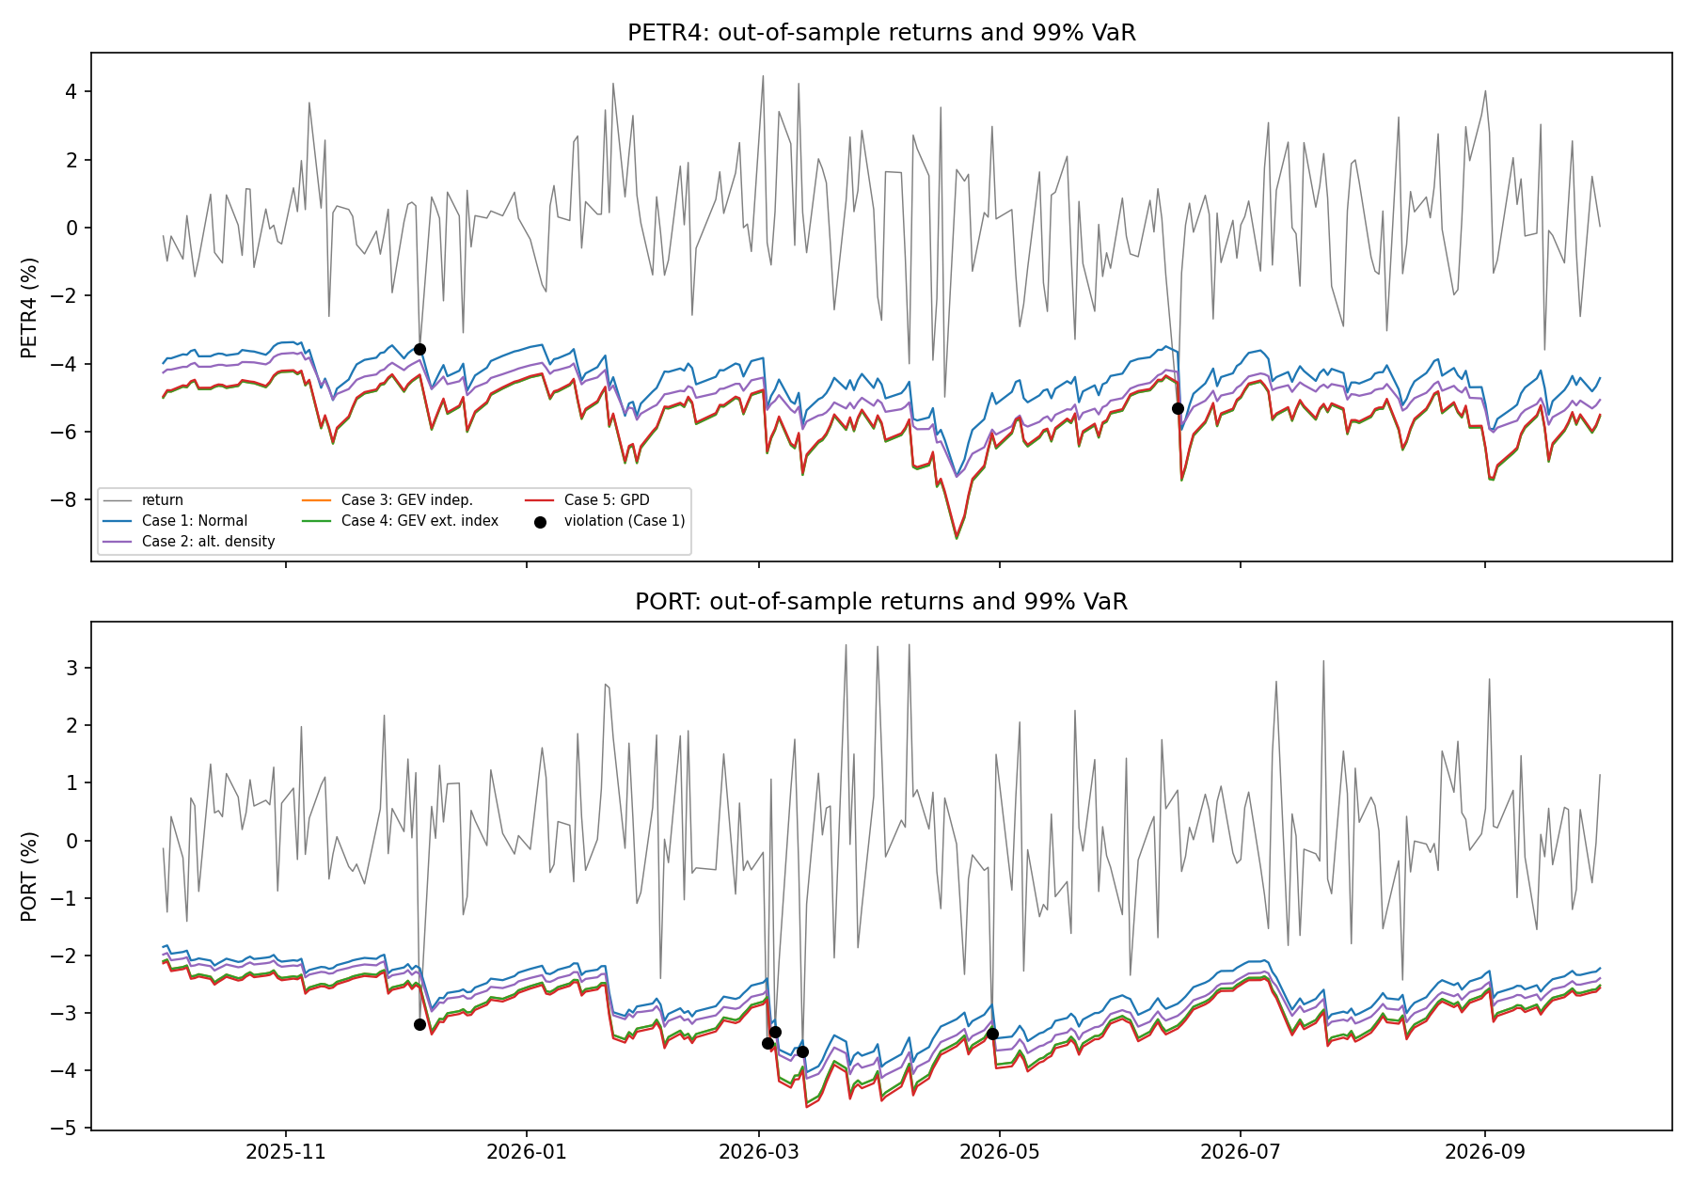
- Level: the Normal VaR is the lowest of the five sequences for both series, the t is in the middle and the three EVT-based sequences are the highest (Table 13). For PETR4 the GEV and GPD VaR are about 25% above the Normal VaR.
- Timing: the VaR jumps right after large negative returns and then decays gradually, as expected from a GARCH model. Violations occur on days when volatility was low and a large shock arrived without warning. For PORT, the Normal VaR is breached on 05/12/2025, three times in early March 2026 (03/03, 05/03 and 12/03) and on 29/04/2026, whereas the EVT-based VaR is breached on 05/12/2025, 03/03/2026 and 29/04/2026 only: the extra margin of the EVT quantile covers the later days of the March 2026 stress episode, which suggests that clustered violations arise when volatility rises faster than the GARCH forecast and the Normal multiplier is too small. For PETR4, the Normal VaR is breached on 05/12/2025 and 15/06/2026, and the EVT cases only once.

8.3 Economic interpretation
- Capital cost of tail realism: moving from the Normal to an EVT-based VaR raises the 99% VaR by about 10% on average, i.e. a bank would need about 10% more capital against market risk. This is the price of removing the excess violations of the Normal model.
- Regulatory traffic light: the Basel framework classifies a 99% VaR backtest on 250 days as green with 0 to 4 violations, yellow with 5 to 9 and red with 10 or more (we use it as an illustration, since the rules apply to a whole trading book). With the Normal VaR, PORT (5), EMBJ3 (6) and VIVT3 (6) would be in the yellow zone; with the EVT-based VaR, PORT (3) and VIVT3 (4) are in the green zone and only EMBJ3 (5) remains yellow.
- Choice of the level: EVT improves the 99% VaR but not the 95% VaR, where the standardized residuals are less spread out than a normal, and where a simple t or the Normal is already adequate. The relevant tool depends on the level of confidence required by the application (trading limits at 95%, capital at 99% or above).

9. Expected Shortfall (Question 9, bonus)
The VaR says nothing about the size of losses beyond it. We compute the Expected Shortfall, ES_alpha = E[L | L > VaR_alpha], at the 95% and 99% levels in two cases (script 09_expected_shortfall.py):
- Case 1 (Gaussian GARCH): ES_t = -mu_t + sigma_t phi(Phi^{-1}(alpha)) / (1 - alpha), i.e. ES_Z = 2.063 at 95% and 2.665 at 99%;
- Case 5 (GARCH and GPD): ES_t = -mu_t + sigma_t ES_Z(alpha), where ES_Z is the GPD expected shortfall of the standardized losses (Table 12; 2.09 to 2.44 at 95% and 2.95 to 4.19 at 99%).
A simple backtest compares, on the days when the return is below minus the VaR, the realized loss with the predicted ES, and we apply the one-sided McNeil-Frey test on the standardized excesses, when at least three violations are available.
 | VaR 99% Normal | VaR 99% GPD | ES 99% Normal | ES 99% GPD
Average over the 16 series (%) | 4.20 | 4.66 | 4.83 | 6.24
Average ES / VaR |  |  | 1.15 | 1.33
Realized loss on violation days (%) | 5.53 | 5.99
Predicted ES on the same days (%) |  |  | 4.60 | 5.88
Table 16. 99% VaR and ES, averages over the 16 series and 249 days.
Series | Case | Violations | Mean ES (%) | Realized loss on violation days (%) | Predicted ES on those days (%) | McNeil-Frey p-value
PETR4 | Normal | 2 | 5.10 | 4.43 | 4.10 | not computed (fewer than 3 violations)
PETR4 | GPD | 1 | 8.10 | 5.30 | 6.71 | not computed
PORT | Normal | 5 | 3.11 | 3.42 | 3.24 | 0.189
PORT | GPD | 3 | 3.94 | 3.36 | 3.65 | 0.809
Table 17. Expected Shortfall at 99% for the two series in focus.
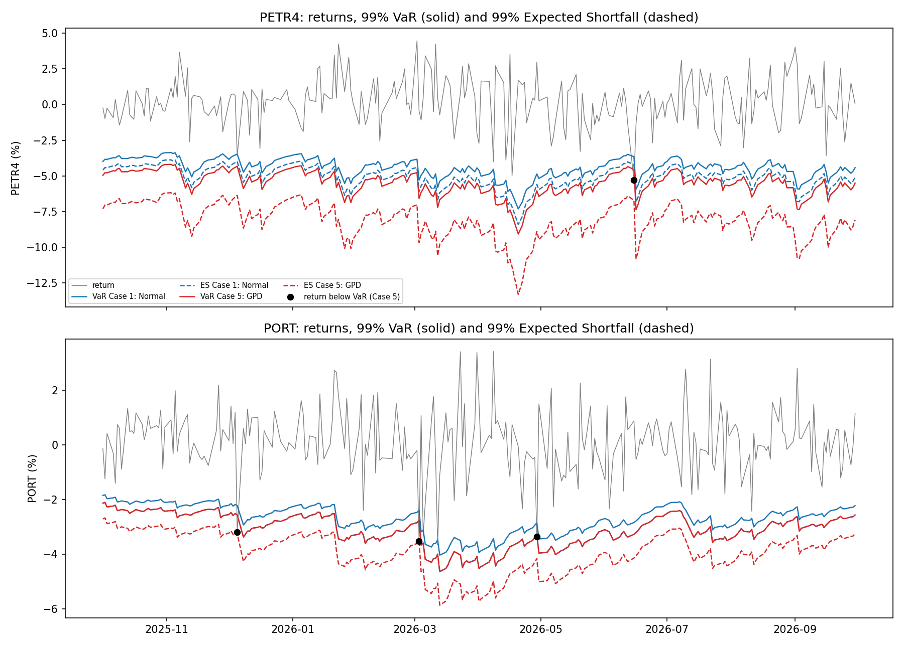
Statistical reading.
- The Normal ES is too low. On days when the Normal VaR is breached, the average realized loss (5.53%) is 17% above the Normal ES predicted for those days (4.60%). The GPD-based ES (5.88%) is within 2% of the realized loss (5.99%). At 95% the same pattern holds more mildly: the Normal underestimates by about 8% (3.94% realized against 3.64% predicted) while the GPD slightly overestimates (3.81% against 3.90%).
- ES-to-VaR ratio: under normality it is almost constant (about 1.15 at 99%), whereas under the GPD it is 1.33 on average and rises to 1.47 for PETR4, reflecting the heavier tail. This is the main message: two models can have similar VaR yet very different ES.
- Formal evidence is weak. The McNeil-Frey test for PORT gives a positive mean excess under the Normal (+0.20, p = 0.19) and a negative one under the GPD (-0.23, p = 0.81), consistent with underestimation by the Normal and prudence of the GPD, but neither is significant given only 5 and 3 violations. The ES backtest is much less powerful than the VaR backtest.
Economic reading. ES measures the average loss in the worst cases, so it is the relevant quantity for the capital needed to absorb a tail event, which is why the Basel Fundamental Review of the Trading Book replaced the 99% VaR with a 97.5% ES for market-risk capital. Our results show that using the Normal for ES would understate the losses given a breach by more than 15% at the 99% level, and that an EVT-based tail model gives a much more reliable estimate.

10. Conclusions and limitations

10.1 Main conclusions
- Brazilian large-cap returns show all the stylized facts of financial data: negative skewness, heavy tails (median excess kurtosis about 10.6), 4 to 6 times more extreme days than under normality, strong volatility clustering, and variance and correlation that jump in crises (average volatility 57.5% and average correlation 0.59 in 2020).
- GARCH(1,1) captures the time-varying volatility (alpha + beta between 0.85 and 0.99, beta significant everywhere) but not the tails: the standardized residuals remain non-normal for all 16 series, and a Student t with 4 to 10 degrees of freedom is the best of four candidate densities for 15 of 16 series.
- Tails of the standardized losses are heavy and well described by extreme value theory: the GEV and GPD shape parameters are positive for 15 or 16 of 16 series (about 0.02 to 0.27), the fits are accepted for most series, and the 99% quantile of Z is between 2.35 and 2.90 against 2.33 for the normal. Extremes are largely isolated after GARCH filtering (extremal index close to one), except for ENEV3, SBSP3 and WEGE3.
- Out of sample, the Normal VaR is too low at 99% (47 violations against 39.8 expected over the 16 series) and its Expected Shortfall underestimates the realized tail loss by 17%. The t and EVT-based VaR (34 to 36 violations) fix this at the cost of about 10% more capital, and the GPD-based ES is close to the realized losses. At 95%, the Normal VaR is already conservative and EVT brings no gain, so the choice of the model should depend on the confidence level.
- Diversification helps but does not remove tail risk: the portfolio PORT has a volatility of 23% against 34% for the average stock, and fewer 99% violations under EVT (3 against 5 under the Normal), but its returns remain strongly leptokurtic, and correlations rise in crises.

10.2 Limitations
- Sample and survivorship: the universe was selected by current market capitalization and a history from 2016 (Suzano had to be replaced because of a share-class conversion), which introduces survivorship bias. The sample is dominated by a single crisis (March 2020), which drives the average skewness, kurtosis, volatility and correlation.
- Currency: returns are in BRL (exchange-rate risk assumed hedged); a USD-based investor would face larger volatility and fatter left tails.
- Data quality: CPLE3 and ENEV3 have many zero returns (stale prices), which weakens their autocorrelation, GARCH and extremal-index estimates. [The group should state here whether the prices were adjusted for splits and dividends.]
- Out-of-sample evaluation: 249 days and about 2.5 expected violations per series at 99% give the backtests little power; conclusions are stronger when aggregated over the 16 series than for a single stock. The ES backtest is weaker still.
- Model choices: a symmetric GARCH(1,1) ignores the leverage effect (asymmetric models such as GJR-GARCH or EGARCH could be compared); the block length (21 days), the GPD threshold (90% quantile), the extremal index estimator and its threshold affect the EVT results (we report the sensitivity for the threshold and the estimator); and the EVT quantiles are estimated once in-sample and not updated, as requested, so they may become outdated after a change of regime.
- Portfolio: the weights are random (log-normal draws) and constant, not optimized, and the portfolio is daily-rebalanced.

11. Use of AI tools

11.1 Tools and purposes
Tool | Purpose | Where it was used
Claude (Anthropic, claude.ai chat) | Guidance on retrieving data in LSEG Workspace and explanation of financial and statistical concepts | Question 1 (screener settings, primary quotes, market capitalization, BRL against USD, adjusting the history, share-class problems such as Suzano) and Question 2 (explanation of the statistics)
Claude (Anthropic) | Writing Python code | Data cleaning (Question 1, 01_clean_data.py) and scripts for Questions 2 to 9 (02_descriptive.py to 09_expected_shortfall.py)
Claude (Anthropic) | Technical help with the working environment | GitHub, VS Code, installation of packages and debugging error messages
Claude (Anthropic) | Drafting of the text and tables of this report from the output files of the scripts | Whole report

11.2 Prompts
The prompts below are reproduced as they were sent to Claude, in chronological order.
Question 1 (data) and set-up
- "How to download daily data from the Refinitiv workspace?" [homework PDF attached]
- "is it possible to download only the date and close price from LSEG ?"
- "how to remove quickly the first 30 lines in each csv file to only keep the data we need ?" [screenshot of a raw LSEG export]
- "can you help me write the code to transform and clean the raw data to only keep csv file with the closing prices?
Question 2
- "this is q2 : On the assets you chose, compute the logarithmic returns and perform a descriptive analysis on the full sample, highlighting if you do have evidence of serial dependence, asymmetry in distribution, and deviations from normality, volatility clustering, and occurrence of extreme events. Comment also on the correlation across your asset returns. Determine if the mean, variance, correlation, kurtosis and skewness are constant over time, ideally using graphical tools. can you write the code ?"
Questions 3 to 9
- "Q4"
- "Q5" followed by the full text of Question 5 of the homework ("Focus now on the standardized residuals Z for the in-sample period and turn them into 'losses'. Fit a GEV assuming independence ...")
- "Q6" followed by the full text of Question 6 of the homework
- "Q7" followed by the full text of Question 7 of the homework
- "Q8" followed by the full text of Question 8 of the homework
- "Q9"
Report
- "if you have all the plots and table needed, you can make the report; I recall you the instructions: [text of the homework instructions]".

12. Appendix: replication material
All scripts are in the GitHub repository, and each one starts with a header that states its input and output, and contains comments that mark where each table is computed, each figure is drawn and each model is estimated. Random numbers are controlled by fixed seeds (123), so that running the scripts in order reproduces the numbers and figures of this report.
Order | Script | Question | Main outputs (folder)
1 | 01_clean_data.py | Q1 | prices_brazil_clean.csv, logreturns_brazil.csv
2 | 02_descriptive.py | Q2 | outputs_q2/ (tables 1 to 7, figures 1 to 8)
3 | 03_garch_portfolio.py | Q3 | outputs_q3/ (weights, GARCH parameters, conditional variances, standardized residuals Z)
4 | 04_var_garch.py | Q4 | outputs_q4/ (normality tests of Z, choice of the density, VaR Cases 1 and 2, GARCH forecasts)
5 | 05_gev.py | Q5 | outputs_q5/ (GEV parameters, fit quality, extremal index, VaR of Z)
6 | 06_gpd.py | Q6 | outputs_q6/ (GPD parameters, fit quality, threshold sensitivity, VaR and ES of Z)
7 | 07_var_evt.py | Q7 | outputs_q7/ (VaR Cases 3, 4 and 5)
8 | 08_var_comparison.py | Q8 | outputs_q8/ (backtests and figures)
9 | 09_expected_shortfall.py | Q9 | outputs_q9/ (ES tables and figures)
Python packages: pandas, numpy, scipy, statsmodels, arch, matplotlib, seaborn. The raw LSEG files are in the folder data_raw/; the scripts read them with relative paths, so the repository can be run from any location after downloading it. Figures not shown in this report (for example the Q-Q plots of Z, the VaR violation timelines, the cumulative violations and the ES-to-VaR ratio) are saved in the output folders.

